Conestoga College - ACS & IT
Programming Microsoft Web Technologies – PROG8551
Assignment #1: Introductory Data-driven ASP.NET Core MVC Web Apps
Due: Sunday June 08, 2025 (by Midnight)
Total marks: 40 Worth: 5%

Introduction
The goal of this assignment is to build a basic database-driven ASP.NET Core MVC web app as a way of getting an overview of ASP.NET Core before we start diving deeper into its various topics like routing, binding, etc. This app will look and behave very similarly to the Movies List web app that is covered in Chapter 4 of our Murach book, as such it will very much be your guiding example! As part of this you will:
- Develop a first basic web app in part I, using the Entity Framework (EF) Core code first approach.
- And then in part II, introduce a change to the data model (and therefore database) as part of an improvement to the web app so that you get a start down the path of using EF Core’s support for migrations.

First, a word of caution
I remind you to make sure you do your own work on this assignment and resist any urge to copy code from any other source - e.g. your classmates, the web, etc. Not only is this the only way to learn how to program but also everyone’s solution will be run through MOSS to check for academic integrity violations. There is zero-tolerance for such violations and any encountered with be dealt with in accordance with Conestoga’s policy. I also remind you that if you are not typing syntactically correct code in yourself, then you are not learning to program! Finally, I’ll note that these assignments are very representative of what will be expected of you on exams so it is very much in your interest to ensure that you are capable of doing them on your own.

Hints
The general idea is that there will be some time to work on these assignments in class and, if necessary, I can offer hints if I see that you are struggling with certain parts. Also, you should try to pace out your work on this assignment over the coming weeks.

How will it be graded?
I’ll say from the outset that there is absolutely no reason to not get 100% - the emphasis here is simple: get your hands dirty coding to solve basic problems and, if needed, I will do what I can to help steer you towards a working and complete solution.

Accompanying each assignment will be an Excel marking sheet that details how your grade will be calculated so you obviously want to make sure that you are doing everything as it’s laid out there.

What/how to submit?
Zip up your entire solution into one zip file and submit that file to the eConestoga dropbox for the assignment.You can submit multiple solutions but only the latest (i.e. most recent) one will be looked at and evaluated.

What will you build?
Suppose some users want an app to keep track of their Blood Pressure (BP) measurements and get some sense of whether or the measurement is high or low or in target range. For this assignment, you will start down the path of building an app to help them by developing an ASP.NET Core MVC web app that:
- Stores BP measurements (i.e. an id, the systolic and diastolic values, the date of the reading, the position they were in for the measurement, and a category for the measurement) in a MS SQL Server (Express or Developer edition) database
- The home/main page of the app will, for now, be very simple and contain only a link to the “all measurements” page and another link to a page to add a new measurement.
- The “all measurements” page will display all the currently recorded measurements in an HTML table with the following columns:
  - Initially (i.e. Part I) just:
    - The systolic and diastolic values of the measurement - e.g. in a BP reading of 120/80 120 is the systolic value and 80 is the diastolic value.
    - The date that the measurement was taken.
  - And then with a migration (i.e. Part II) you will add:
    - A category and a position for each measurement
  - Please see below for more details on these properties and the screenshots at the end of the assignment to get a better sense of how this should look and behave.
- Provide a link on the all measurements page that takes the user to a new page with a form to add a new measurement
  - On that page the user should be able to enter valid fields for a measurement and add it to the database and then get returned to the all measurements page
- Each measurement in the HTML table, on the all measurements page, will be accompanied by two action links:
  - An Edit link to edit the existing measurement, which takes you to a form filled in with the measurements’s current values and a button to update the measurement if altered.
  - A Delete link to delete the existing measurement, which takes you to a page that the user can use to confirm they want to delete it.
  - Both these pages should do the desired edit/delete action in the database and then return the user to the all measurements page
- All the action pages: Edit, Add, Delete should also have a cancel button that takes you to the “all measurements” page
- Your web app should also use the basics of ASP.NET Core’s validation capabilities to ensure that:
  - All properties should be required
  - Systolic & Diastolic should both be integers, and Systolic should be between 20 and 400, and Diastolic should be between 10 and 300
  - Note, about the measurement date: dates are tricky so the jQuery-ui’s datepicker is a very good option for allowing users to enter/edit dates. A demo of its use will be done in class.
- Also, if the user attempts to add/edit a measurement with invalid fields then the add/edit attempt should be abandoned and appropriate and informative error messages, in red, should be returned to the user. Again, see the screenshot below for reference.
- Also, seed your database with at least 5 measurements.
- Database naming convention: because I want to be able to easily run each of your solutions, it is very important that you abide by the following naming convention for your database so that your databases don’t clash on my machine when grading, namely:
  - Use this format to name your databases: BPMeasurements<YourDomainLoginName>
  - For example, if your domain login name (i.e. what’s before the @ sign in your Conestoga email address) is SJones1234, then you should name your database:
    - BPMeasurementsSJones1234
  - Note: If I am unable to run your web app because of a violation of this naming convention you will lose marks!
- On the “all measurements” page, highlight the successful completion of each action, i.e. add/edit/delete of a measurement using the last action message approach demonstrated in class.

Using Entity Framework (EF) Core to develop data-driven web apps is very elegant and powerful but it also comes with its own subtleties and challenges, but a key aspect of it is its support for continually evolving your data model through the use of migrations. As such, just as the authors of the Murach book do in chapter 4, in this assignment you will complete the app in 2 parts so that you can evolve the app using a migration. That is, to get full marks on this assignment you need to include an initial migration and a second migration that adds the Position to be associated with a measurement. Thus we break the assignment down into 2 parts...

Part I:
Get a basic version of the app working that focuses first on only the following fields: systolic and diastolic values, and the date of the measement. Here is a screenshot of the “all measurements” page of the app after this initial step:

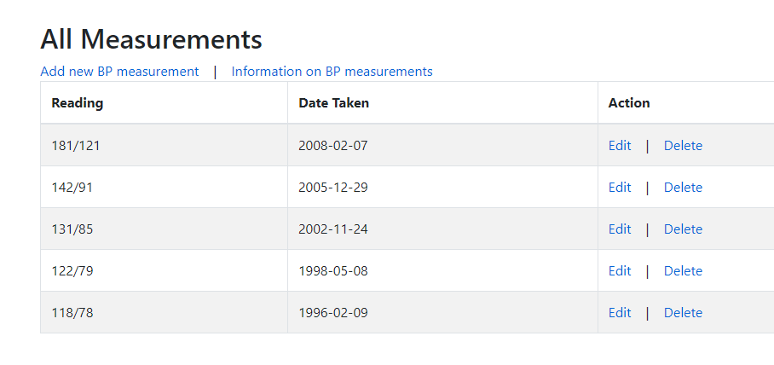

Part II:
Just as the authors of the Murach book do in chapter 4 with the Movies List web app, wherein they add a migration that supports a movie Genre, in this part you will add a Position class (i.e. a class of objects representing the position the person was in when the BP measurement was taken, e.g. the measurement was taken when the person was “Sitting”) to your model and update the database accordingly. That is, to do this you will:
- Adds a Position class that has 2 properties:
  - A string ID (that will correspond to its primary key in the database)
  - A string name property
- And then seed the DB with instances for each of the 3 positions, namely: Standing, Sitting, Lying down, using an ID of your choosing and update the seeding of the original data accordingly
- Once done, add the new migration and update the database.
- Next, you will add a method or readonly (i.e. get only) property - your choice - that returns the category for a BP reading based on the following chart:

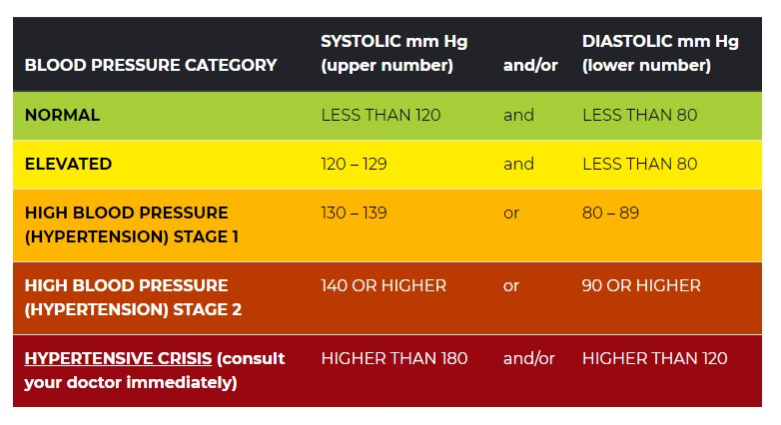

- That is, use the following as your categories (and corresponding colours):
  - Normal (dark green)
  - Elevated (blue)
  - Hypertension Stage 1 (orange)
  - Hypertension Stage 2 (orange red)
  - Hypertensive Crisis (dark red)
- And then, in the “all measurements” page, add a new column that uses your method or property to display the category for each reading in a new column and colour code the reading in accordance with the category - i.e. as shown in the chart above and in the screenshot below.

Screenshots of the Final Web App
The following are screenshots of the final (i.e. after Part II is completed) Web App to help give you guidance. First, the “all measurements” page:

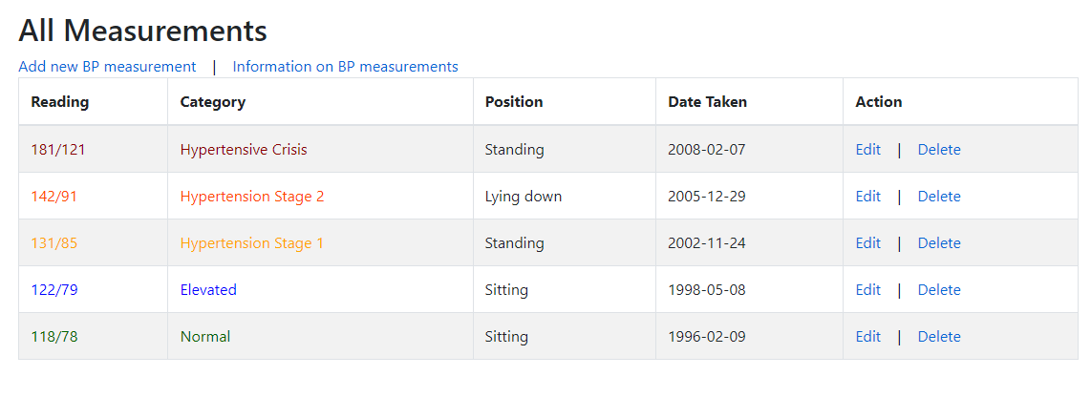

The “Add” page:

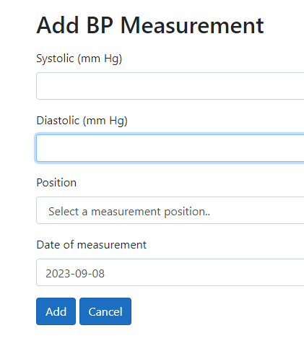

The “Edit” page:

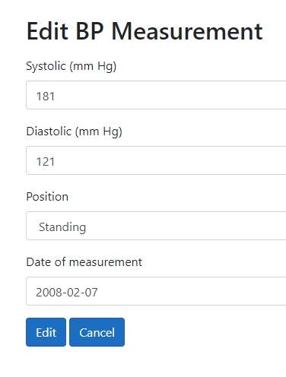

The “Delete confirmation” page:

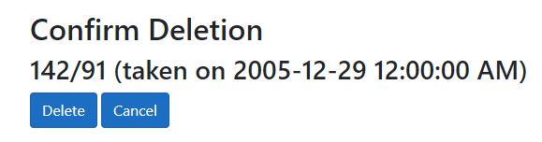

And finally, a page highlighting some validation errors:

